(Approx. 3507 words)

Windows 10 – The Good, the Bad, and the Ugly
What if you DON’T want to upgrade to Windows 10?
By Wayne B’Rells, Member, Hendersonville Area Computer Society, NC
www.hacs.org
jerry (at) liedl.org

As discussed in the next sections, there are many situations where it may be better to stick with Windows 7 (or even, possibly, with Windows 8.1). Unfortunately, Microsoft is getting more and more aggressive in its attempt to force you to upgrade to Windows 10.

The best way of removing all those annoying messages about upgrading to Windows 10 (and prevent them from coming back!) is to download and install the program GWX Control Panel. Just go to:
http://ultimateoutsider.com/downloads/

and click on the first item, GWX Control Panel. This will download the file
GwxControlPanelSetup.exe. Double click on this file to execute it. If necessary, give the program permission to run and allow the GwxControlPanel to be installed in the default directory. Once the installation has finished (which will only take a few seconds) you should have this icon ( ) on your desktop. Double click this icon to start the program. After agreeing to the license agreement you should see a window similar to this one:

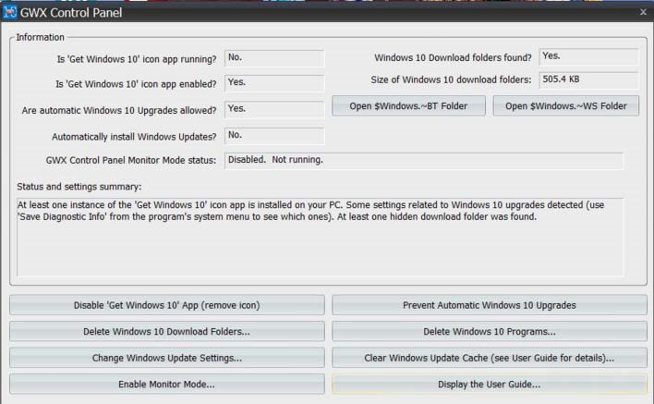

For detailed help you can click on Display the User Guide..., but really it seems that all you really need to do is:
- Click on Disable 'Get Windows 10' App (remove icon)
- Click on Prevent Automatic Windows 10 Upgrades

The item Automatically install Windows Updates? in the top window is likely to say Yes. The general consensus is that you should NOT allow Windows to automatically download & install updates. If you click on the button Change Windows Update Settings... you can choose from several options. The one I'm using is:
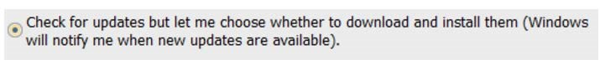
That way you can review any updates and (hopefully) decline any that specifically mention Windows 10.

Should You Update to Windows 10?

- Situations in which an upgrade to Windows 10 may be very desirable or even essential:
  - If you are running Windows XP (which no longer receives security updates!) or even Windows Vista I strongly suggest you upgrade to Windows 10 ASAP. Unfortunately, these systems do not qualify for a free upgrade so I’d suggest purchasing a new system with Windows 10 pre-installed!

  - If you are running Windows 8.1 I’d suggest updating to Windows 10 to get rid of the many annoyances that were introduced with that system.

  - Windows 10 provides a new, quick and effective way of changing the size of EVERYTHING on your screen. This is particularly helpful with newer high-resolution screens that often default to really tiny icons and text. (This improvement – just by itself – may justify the upgrade!)

  - Windows 10 includes a number of programs/features that previously had to be purchased or at least downloaded from questionable web sites. Again, these features will be discussed a bit later. The Windows 10 firewall & antivirus features have been improved (compared to Windows 7), but I would still recommend a 3rd party firewall/antivirus package for more complete protection.

  - Installing new hardware (such as printers) has become much more automatic. Microsoft maintains a huge online library of device “drivers”, so many times you just need to connect the new device and it will be automatically installed.

  - Until July 29, 2016 the upgrade to Windows 10 is “free”. After that, upgrading an existing system is likely to cost $100+.

  - Microsoft has stated that Windows 10 will be the LAST version of Windows – there will NOT be a Windows 11, Windows 12, etc. This does not mean that Windows 10 will be “frozen” in its current configuration. Microsoft will be adding features and fixing “bugs” on a regular basis, but the general appearance and operation of Windows should not drastically change. Therefore, if you “learn” Windows 10 now there should not be another sharp “learning curve” (as there was for Windows 8/8.1)

- Situations when an upgrade to Windows 10 may not be desirable:
  - Your computer may be incompatible with Windows 10 or require some updates before it can successfully run Windows 10. I’d suggest you do a Google search on your exact PC model to see if it is compatible.

  - Your system might be compatible with Windows 10, but may be too slow or have too little disk space to run Windows 10 at an acceptable speed. Systems that are 5+ years old are almost certainly too slow for Windows 10.

  - Updating your system will require you to learn at least the basics of Windows 10. The standard Windows 10 interface is a combination of Win XP / Win 7 and the totally alien Win 8 approach. If this change proves too annoying, I’d suggest installing the Classic Shell program that makes the Windows 10 interface almost identical to that found in Windows 7.
  - Something might go wrong during the update. In the worst case, your computer could be turned into an expensive “brick”! Although anything so disastrous is very unlikely to occur, I strongly recommend that you make a complete backup (otherwise known as an “image backup”) of your system before proceeding with the upgrade.

  - Some features of Windows 7/8 will be lost.

    - Media Player will no longer play commercial (i.e. copy protected) DVDs. For $15 Microsoft will, supposedly, sell you a license to re-enable the playing of such DVDs. A better solution, however, is to install the free – and much more flexible – VLC program from http://www.videolan.org/vlc/download-windows.html

    - Outlook Express is no longer provided. It has been somewhat replaced by the Mail “Universal Windows App” and/or Live Mail. Neither of these programs is a direct replacement, so this might be a good time to start using the web (i.e. browser-based) interface of your chosen email client.

    - Internet Explorer is being “deprecated” (i.e. “phased out”) in favor of Microsoft’s new Edge browser. Edge is still a work-in-progress, so at least for now it might be better to use either Chrome or Firefox. (Note: Internet Explorer 11 can still be found in the list of “Apps” provided with Windows 10, but by default it does not appear on the Desktop or on the Task Bar.)

- Some old programs may not work under Windows 10. Examples include a number of old games and older version of Quicken. In my own experience, however, Windows 10 has managed to run some old XP-version programs without any problems. (The so-called “compatibility mode” feature of Windows 10 seems to work very well – better, perhaps, than it did under Windows 7/8.) Also keep in mind that no versions of Windows 10 include the “XP Mode” option available with the Professional version of Windows 7.

- If you are running commercial (i.e. non-free) programs on your existing system you should investigate how those program can be moved to a new system. Some programs may just “move over” to Windows 10 without any problems, but others may treat Windows 10 as a new system and require a reinstallation with potential licensing concerns. If you buy a new PC you will almost certainly need to reinstall such programs. (Often, such programs will need to be CAREFULLY uninstalled from your old system so your license can be used with the new system!)

- By default, Windows 10 will send a LOT of information to Microsoft! This information may, apparently, include information on your browsing history, your contacts, your location, etc. In addition, the Windows Update process will use YOUR Wi-Fi connection to update OTHER PCs. (This is a so-called peer-to-peer method of networking that utilizes “rings” of PCs to speed up the downloading of large files.)

Many people feel that this default behavior of Windows 10 represents a violation of user privacy. Fortunately, the more egregious aspects of this behavior can be turned off when Windows 10 is first installed or – more commonly – immediately after the system is installed. Details are given below.

- Updates to Windows 10 (at least the home edition that most people are using) cannot be blocked. (Under Windows 7 and 8 the user could request that they be notified when updates were available, but they could choose when – or even if – an update was installed.) The new “forced updating” policy has been very controversial, but should not be of concern to most users. If an update causes trouble it can be uninstalled, assuming that it has not rendered your system inoperable. In that case, you will need professional help! (A partial workaround to this problem is described below.)

Methods of Upgrading – Doing a “Clean” Install
Assuming that an Upgrade to Windows 10 is desirable, the easiest way of doing so is to accept Microsoft’s offer to upgrade your system. This approach will not only preserve all of your existing programs and settings (hopefully) but will also preserve leftover remnants of deleted programs along with files that are no longer of use. All this leftover “stuff”, along with a registry containing a lot of obsolete information, will undoubtedly cause your “new” Windows 10 system to run slower than it should.

One way around this problem is to do a “clean” installation of Windows 10. This approach is not for the “faint of heart” since it requires (after doing the initial installation) that ALL programs and user files be reinstalled! (It is essential, obviously, that you securely back up your existing system onto an external hard disk before proceeding with this approach. Be sure that your backup program – which you will also need to install on your new system – can access individual backed-up files!)
Should you decide to pursue this approach, Download Microsoft's Windows 10 media creation tool from https://www.microsoft.com/en-us/software-download/windows10 . Download and run the MediaCreationTool.exe. Select "Create installation media for another PC" - See more at: http://www.laptopmag.com/articles/clean-install-windows-10. (Note: The above-mentioned Microsoft web site also gives the option of updating your current machine to Windows 10.) ➔ This approach can also be used – and I have done this several times – with a just-purchased Windows 10 system to eliminate all the “garbage” that is normally included with such systems.

No matter what approach is used to upgrade to Windows 10 you will be given an option of using either a local account & password (just like under Windows 7) or a network-based Microsoft account. The latter option, strongly “pushed” by Microsoft, requires you to have (or set up) a Microsoft account tied to an email address (which does not have to be a Microsoft mail address). Using OneDrive, Microsoft’s free cloud-based storage, requires a Microsoft account as does the Contana option mentioned below. Using a Microsoft account also allows a quicker but still secure login to Windows using (typically) a 4 digit PIN number rather than a complicated password (which can also be used to login in case the PIN number method fails, which I find happens quite regularly). Fortunately, it is quite easy to switch from one type of login to the other if that seems desirable.

Using Windows 10 Safely

Many people have complained that, by default, Windows 10 will send a great deal of potentially private information to Microsoft, supposedly to improve the “user experience”. In practice, though, much of this information is used to support directed advertising and (perhaps) some other questionable activities. In addition, the default settings make it easier for other people to share your Wi-Fi connection. Fortunately, it is not difficult – although slightly tedious – to block such activities. Blocking can be done during installation and/or at any time after installation. I recommend, though, that you make these changes ASAP as described below!

Early on during the upgrade process you will be presented with the window shown below. Notice that Microsoft clearly wants you to choose the Use Express settings option. This is not the best choice, since that option will leave your system “wide open” to the potential abuses mentioned in the previous paragraph. Instead, I would suggest clicking on the somewhat obscure Customize settings option shown in the lower-left corner of the window:

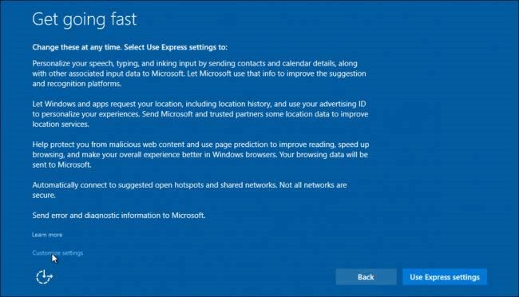

NO!

You will now be shown a series of screens that will allow you to turn off most of the data/Wi-Fi sharing that may cause privacy concerns. I can’t remember the exact order in which these screens are presented, but they are basically a subset of the screens described below. No matter how careful you are during the installation of Windows 10 I suggest you review the privacy settings described here. Most of these settings are accessed by clicking on the Start button and going to Settings > PC settings >Privacy. You will then see this window: 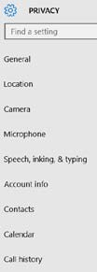 ⬅(scroll to see more entries )

Many of these entries (General, Location, etc.) are shown in more detail below, but my general recommendation is to turn OFF almost all of the sharing, “improvement”, etc. options and then turn individual options back ON only if needed.
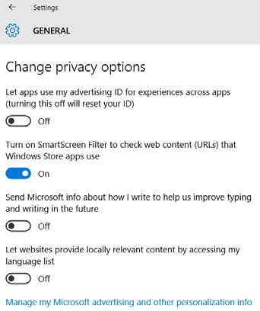 | 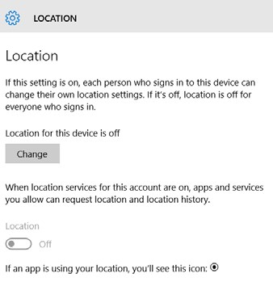 | 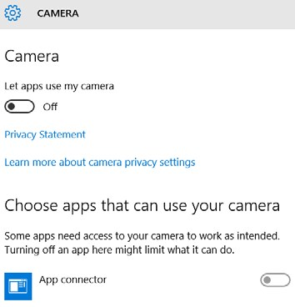
The SmartScreen Filter can be turned Off if you are not using the Windows Store | I suggest making sure this setting is Off. (Change to Off  if necessary) | Will only need to be On if you use the camera for Skype, etc.
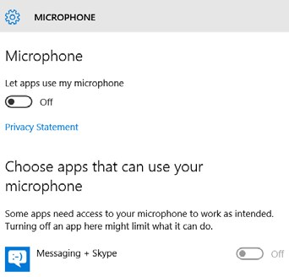 | 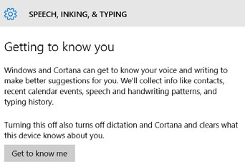 | 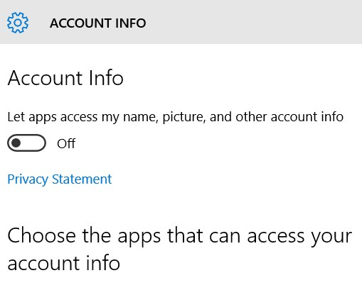
Should be Off unless using Skype, etc. | Don’t click on Get to know me. Be sure this option is not active! | Almost certainly should be Off!

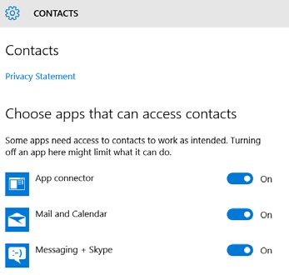 | 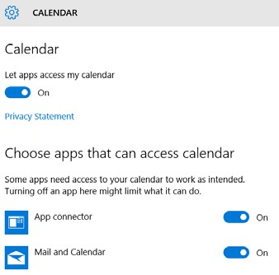 | 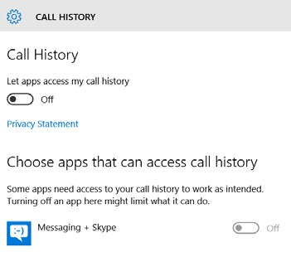
I left On a few of these options, but probably should not have! | Again, I just left On a couple of these… | Perhaps useful if using Skype or similar…
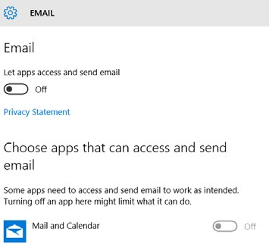 | 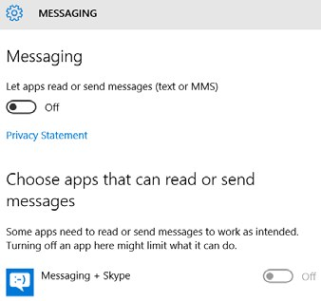 | 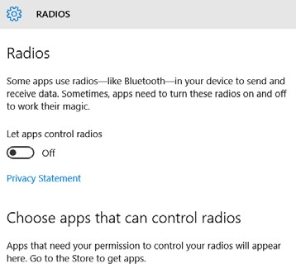
I’m not using Microsoft’s email client so I I completely turned Off this option. | May need to be On for certain applications such as Skype | Apparently, only needs to be  On if using Bluetooth to connect to other devices
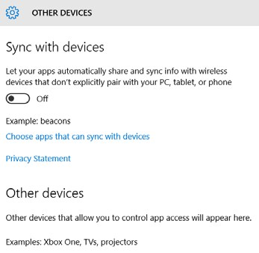 | 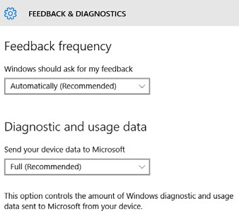 | 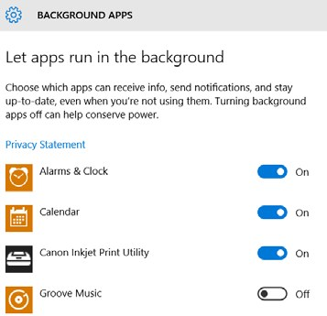
Almost certainly should be Off! | I don’t want to be too hard on  Microsoft, so I left these options active | Probably only the Print Utility program really needs to stay  running…
In addition to these relatively obvious options there are several other privacy-related settings that should be checked. By default, Windows 10 will try to get updates from both Microsoft’s own computers and from private computers owned by other individuals – including YOU! That is, computers owned by complete strangers will be able to download Windows 10 update files from your computer. This type of downloading is called peer-to-peer sharing and results in faster and more efficient use of the internet. HOWEVER, it does mean that you are sharing your internet bandwidth with strangers! I suggest that you click on the Start button and go to Settings > PC settings > Update & security > Windows Update. Now click on Advanced options near the bottom of the WINDOWS UPDATE window to bring up:
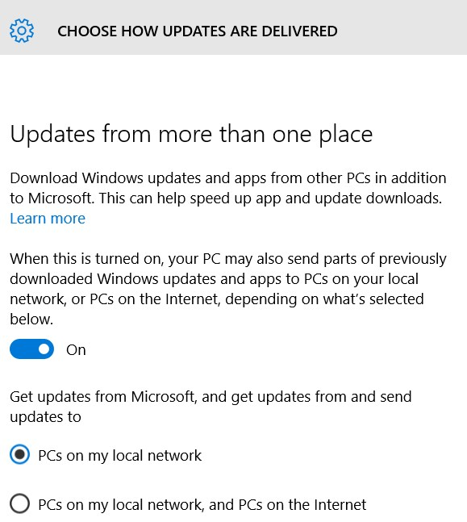

I suggest leaving the switch On, but select PCs on my local network and not PCs on the Internet, and PCs on the Internet.
The next item relates to Wi-Fi “hot spots” and the ability of other people to access your Wi-Fi connection. Click on the Start button and go to Settings > PC settings > Network & Internet > Wi-Fi. Now click on Manage Wi-Fi settings option (which is below the list of available Wi-Fi connections). You should see:
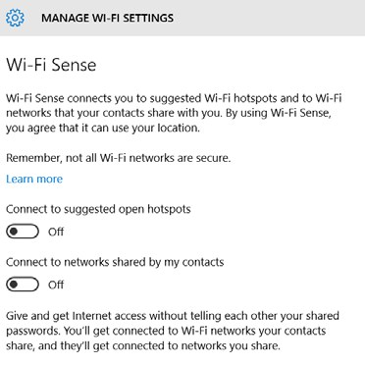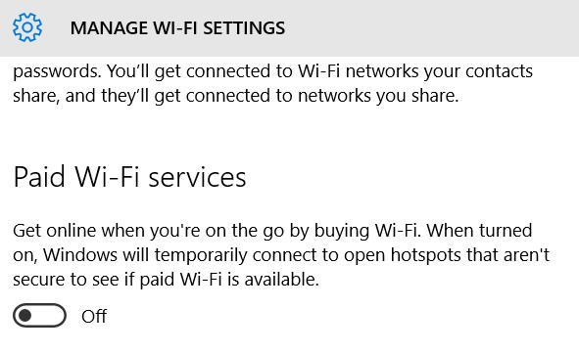

For safety sake, I’d suggest turning Off all of these options!

Controlling Windows 10 Updates

By default (and this has been a very contentious issue in the Windows 10 community) you have very little control over the downloading and installing of updates. You can, however, gain a little more control over WHEN but not IF downloads occur. The option I’m going to discuss is called a “Metered connection”. This option was provided mainly for the benefit of folks using a cellular data connection with monthly data allotments. Using the “Metered connection” option will prevent downloads until the user gives the go-ahead, perhaps after they have established a Wi-Fi connection at their local StarBucks! However, I find this option useful at home because it prevents your work from being interrupted because Microsoft decides it is time to download and install an enormous update! (You will be notified that updates are available, but will be given the option of doing the download and installation later.)

To activate the Metered connection option, click on the Start button and go to Settings > PC settings > Network & Internet > Wi-Fi. Now click on Advanced options (which is below the list of available Wi-Fi connections). You should see:

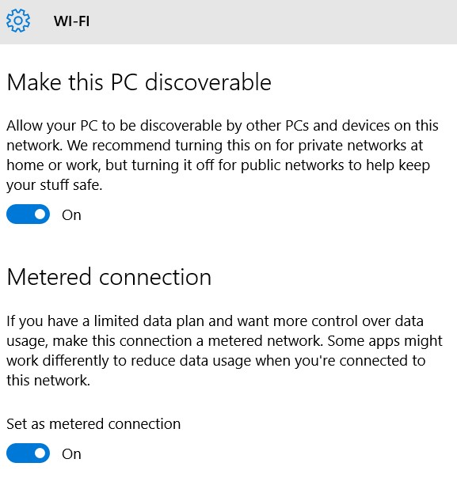

Only if you have a wireless printer or other such wireless device.

The first option – Make the PC discoverable – will probably need to be On if you are using any wireless devices such as a printer. If you are NOT using such devices you can turn this option Off. The second option – Metered connection – can be turned On to gain the benefits mentioned above. I understand that this option only applies to Wi-Fi or cellular data connections – it is not available if your computer is directly connected to your router via an Ethernet cable.

New/Updated Windows 10 Features & Programs Other Recommended Programs
Here are some built-in programs that I can recommend:

- WordPad – An extremely stripped-down version of Microsoft Word. This simple-to-use program should be adequate for writing letters and short reports.

- Windows Media Player – The Win 10 version of Media Player cannot show commercial DVDs (due to licensing restrictions) but it can still be used to play music CDs.

- ZIP files – Not a separate program, but a feature built into Windows 10 that allows you to create a ZIP file or expand an existing ZIP file. To ZIP: Select files, right-click, select Send to and then Compressed (zipped) folder. You can then choose the name of the ZIP file (actually, a folder). To un-ZIP a ZIP folder: Right-click on that folder and select Extract All… which will give you a choice of where the un-ZIPed files are to be stored.

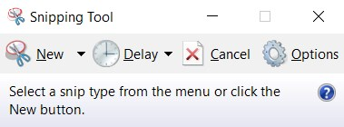

- The Snipping Tool This tool – which I suggest “pinning” to the Task Bar – allows you to select and then save or print any desired rectangular section of your screen. Just left-click on the above icon (assuming you have put it on the Task Bar) to bring up:

Clicking on New will bring up a background that you can move and resize with your left mouse button to select any section of the screen. When you release the mouse button you will have “captured” that area of the screen. You can now use the File > Print… option shown here:
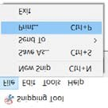

to print that area, or you can use the Edit > Copy option shown here:
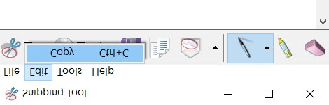
which will copy the selected area to the Clipboard (from where it can be pasted, for example, into a word-processing document.

One highly-advertised (by Microsoft) new feature is Contana, a search option that shows up prominently next to the “Start” icon on the left side of the Task Bar. (I do not use this “feature” and have hidden it on my system.) Cortana allows (assuming your system has an active microphone) voice-based searches in the manner of Apple’s Siri, but is apparently not as sophisticated. If you type text into the Cortana “box” it will search your system and the Internet. I found this behavior annoying when all I want to do is search for something on my system. (I use Chrome/Google to look for things on the web.) Finally, to increase its advertising revenue, Microsoft has modified Cortana so it will only use Edge and Bing when searching the web. It is no long possible to have Contana use competing products such as Chrome and Google.

The other programs that I recommend are from 3rd parties:

- Reflect – Free version of Macrium Reflect, the system backup program that I highly recommend.

- Malwarebytes – The free version of an antimalware program that complements whatever antivirus program you may be running. I suggest running Malwarebytes at least once a month. Download from https://www.malwarebytes.org/mwb-download/ being sure to choose the free version of the program. Also, when installing, be sure to un-check the option for activating a 30-trial of the non-free version of the program!

- CCleaner – A well-respected program for deleting leftover bits of software, etc. that inevitably accumulate on a PC over time. The default settings are generally the safest choice. Download from https://www.piriform.com/ccleaner/download and be sure to choose the free version!


- Irfanview – A program for showing almost any graphic/image file. Much more powerful than the image-viewing routines included with Windows 10. Download from http://www.irfanview.com/. Just click on the button.

- Foxit Reader – An alternative to Adobe Acrobat Reader DC (the latest version of Adobe Reader). The Adobe’s offering has become terribly “bloated” over the years and is now very much cloud-oriented. I strongly recommend the free Foxit Reader instead:


Download from https://www.foxitsoftware.com/products/pdf-reader/

- LibreOffice – An outstanding free replacement for the Microsoft Office suite of programs. LibreOffice will directly read and write Microsoft Word files. Warning: Like Microsoft office, this is a large, complex set of programs that can take a long time to fully master. However, simple documents can be produced quite easily and a lot of online documentation (including video tutorials) is available. Download from https://www.libreoffice.org/download/libreoffice-fresh/ Click on the green DOWNLOAD … button, but note that the large size of this packages means that the download may take some time:

